**Hillswick Wildlife Sanctuary**

**Art Competition & Exhibition, Islesburgh**

**17 – 30th April 2020**

**Adult - Anonymous Art Competition**

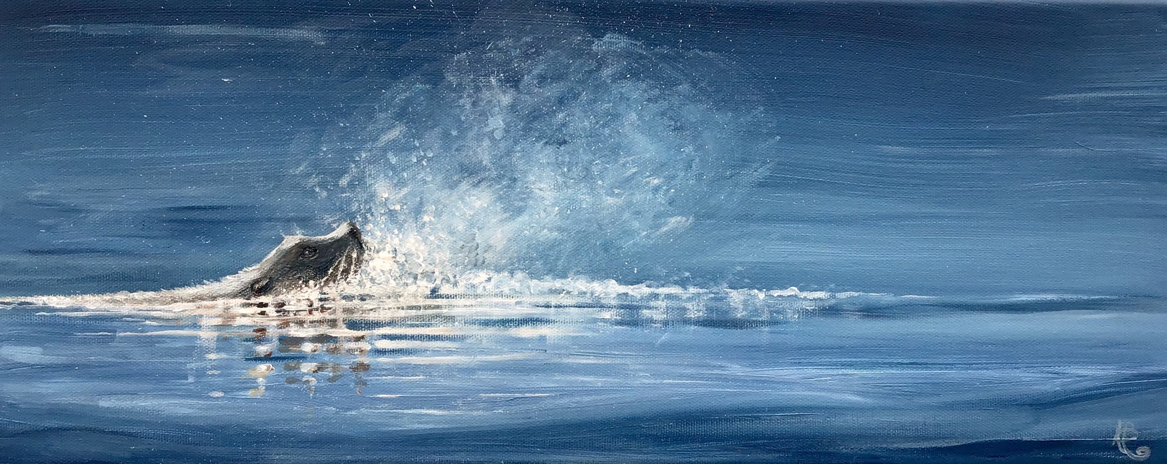

Please fill in this form and return it to the address below by Friday 3rd April. The painting should be delivered to Room 12, Islesburgh on Friday 17th April between 1pm – 8pm along with your £5 entry fee. You should keep the terms and conditions for reference re dropping off and collecting times. If you are posting the artwork, it should be sent with the form and fee by 3rd April to the address below – your fee could be enclosed as a cheque or paid by Paypal to [wildaboutart@yahoo.co.uk](mailto:wildaboutart@yahoo.co.uk). Please note if your artwork is unsold at the exhibition and you want to have it returned, you will have to send extra money to cover the return postage.

Name:

Address:

Telephone No: Email:

Title: Medium:

Your donated picture must be 8” x 8” including any mount / frame. Canvases or suitable boards can be 8” x 8” unframed but must have cord or wire on the back so they can be hung on a wall. They can be in any painting, drawing or craft medium, including collage, textile work, etc. It must be signed only on the back, must have a label with your contact details on the back, must be handmade by yourself and never have been exhibited, published or shown on social media as the artwork must all be anonymous. Each piece will be sold for £45, and the proceeds will be divided between the Shetland MRI Scanner and the Hillswick Wildlife Sanctuary. We realise for some artists this is a very low price, but the idea of the exhibition is that people can buy anonymously and may find they have bought an absolute bargain, but in every case will have bought a painting they love, whatever it’s pedigree. The theme is “Our Precious World” and can be anything to do with wildlife, climate change, saving the planet, plastic pollution or conservation. All images will be displayed and there will be a winner and runner-up, judged by an appointed panel, with the prize-giving at Islesburgh, Room 12 from 2.00 pm on Sunday 19 April, all welcome.

Any unsold pictures will be taken down on Thursday 30th April and can be collected between 2.00 and 5.00pm. Please advise if you wish to collect after this date, or you wish the image to be returned by post.

All queries and correspondence please to:

Mrs A Barron, (Bailey & Barron) Duncansclate, Bridge End, Shetland, ZE2 9UY.

Email: [wildaboutart@yahoo.co.uk](mailto:wildaboutart@yahoo.co.uk)

Tel 07713985081

I have read and I agree to the terms and conditions (attached)

Signed:

**Hillswick Wildlife Sanctuary**

**Art Competition & Exhibition, Islesburgh**

**17 – 30th April 2020**

**Adult - Anonymous Art Competition**



Please fill in this form and return it to the address below by Friday 3rd April. The painting should be delivered to Room 12, Islesburgh on Friday 17th April between 1pm – 8pm along with your £5 entry fee. You should keep the terms and conditions for reference re dropping off and collecting times. If you are posting the artwork, it should be sent with the form and fee by 3rd April to the address below – your fee could be enclosed as a cheque or paid by Paypal to [wildaboutart@yahoo.co.uk](mailto:wildaboutart@yahoo.co.uk). Please note if your artwork is unsold at the exhibition and you want to have it returned, you will have to send extra money to cover the return postage.

Name:

Address:

Telephone No: Email:

Title: Medium:

Your donated picture must be 8” x 8” including any mount / frame. Canvases or suitable boards can be 8” x 8” unframed but must have cord or wire on the back so they can be hung on a wall. They can be in any painting, drawing or craft medium, including collage, textile work, etc. It must be signed only on the back, must have a label with your contact details on the back, must be handmade by yourself and never have been exhibited, published or shown on social media as the artwork must all be anonymous. Each piece will be sold for £45, and the proceeds will be divided between the Shetland MRI Scanner and the Hillswick Wildlife Sanctuary. We realise for some artists this is a very low price, but the idea of the exhibition is that people can buy anonymously and may find they have bought an absolute bargain, but in every case will have bought a painting they love, whatever it’s pedigree. The theme is “Our Precious World” and can be anything to do with wildlife, climate change, saving the planet, plastic pollution or conservation. All images will be displayed and there will be a winner and runner-up, judged by an appointed panel, with the prize-giving at Islesburgh, Room 12 from 2.00 pm on Sunday 19 April, all welcome.

Any unsold pictures will be taken down on Thursday 30th April and can be collected between 2.00 and 5.00pm. Please advise if you wish to collect after this date, or you wish the image to be returned by post.

All queries and correspondence please to:

Mrs A Barron, (Bailey & Barron) Duncansclate, Bridge End, Shetland, ZE2 9UY.

Email: [wildaboutart@yahoo.co.uk](mailto:wildaboutart@yahoo.co.uk)

Tel 07713985081

I have read and I agree to the terms and conditions (attached)

Signed: